**Finding location for new Starbucks**

* **Discussion of background:**

Manhattan is a big city and good for business investment to start new branch of Starbucks. Now the problem is where to Put the Next Starbucks in Manhattan?  
The following illustration was created from data obtained using the Foursquare API (Application Program Interface). Like all Science experiments, Data Science begins with asking a question (hypothesis); in this specific illustration the question is, "Where to put the next Starbucks in Manhattan?"

* **Data Description:**

The following assumptions are considered to illustrate problem.First, our marching orders from Starbucks are they want to chip away at their competitors' market share (after all, business is a war sometimes fought by squeezing out the competition). Second, where Starbucks' competitors are most densely located in Manhattan are high foot traffic and high coffee demand areas most frequented by coffee consumers/coffee shop patrons. Third, the data provided by the Foursquare API is accurate and all-inclusive. Since the data is crowdsourced and as we know, us humans are fallible, there may be some discrepancies in the data.   
  
For this reason, Starbucks have to provide their current locations in some written form. Therefore, Starbucks could not come back and claim their current location data is not accurate, as they would be the ones who supplied this data in the first place (and I would have the written documentation to prove it).

* **Methodology**  
    
  Below is a map created showing the locations of Starbucks' competitor coffee shops in Manhattan (the map was made using Python, the Foursquare API data, and Python's Folium mapping library):  
    
    
  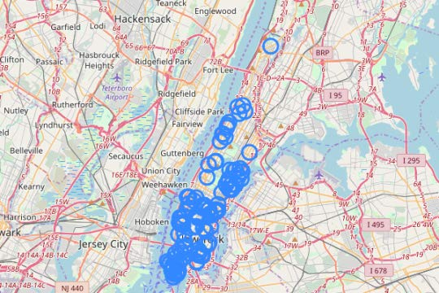  
    
    
  Here is a more close up view of the same map of Starbucks' competitors' locations so the more dense areas can be viewed with better resolution:  
    
    
  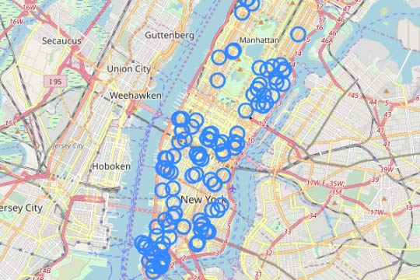  
    
    
  The map below shows Starbucks' current Manhattan locations based on the Foursquare API data:  
    
    
  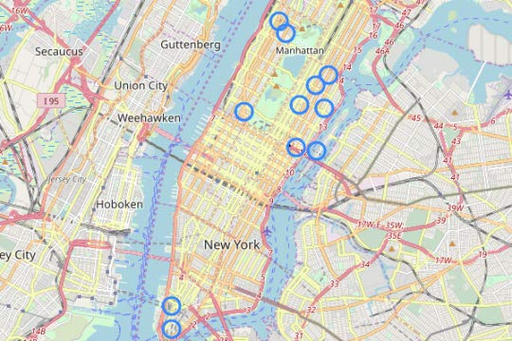  
    
    
  **Data Analysis**

The benefits of using Python for data analysis are the myriad of mathematical and machine learning algorithm libraries available.   
  
For this particular business problem, the k-means clustering algorithm is used to find the best location for the new Starbucks in Manhattan.   
  
Explaining in detail how the k-means machine learning algorithm works is beyond the scope of this post, however, for those who would like to explore this further here is a link with more information:  
  
[k-means Clustering Algorithm](https://www.datascience.com/blog/k-means-clustering)  
  
In a nutshell, k-means puts data into groups, called clusters, based upon measuring distance between data points (coffee shop locations in this case). The data is grouped into various clusters over and over again until the center of the cluster no longer moves. The center of the clusters is then mathematically defined (the center of each cluster is called its centroid).   
  
From the map of Manhattan, the locations on the map, and the geography of Manhattan, the number of clusters assumed here is three (representing Lower Manhattan, Central Manhattan, and Upper Manhattan).   
  
The three centers (centroids) for the locations of Starbucks' competitors' coffee shops were computed mathematically and plotted on the map below:  
  
  
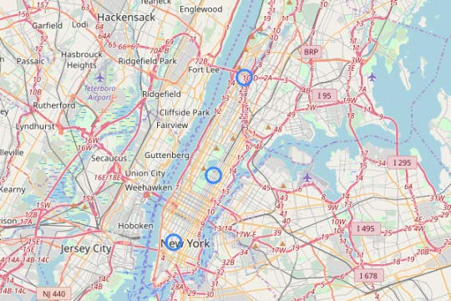  
  
  
Based upon these computations, the best location for the new Starbucks in Manhattan is Lower Manhattan's Washington Square Park, with the calculation specifying, Latitude:40.731130, Longitude: -73.997801.   
  
This above location is magnified below for a clearer view:  
  
  
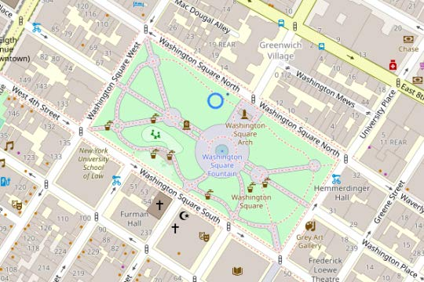  
  
  
**Results:**

Obviously, Starbucks cannot put a brick and mortar coffee shop right in Washington Square Park. However Starbucks should try to find a location as close to this point as possible.   
  
Knowing the sky high cost of opening a brick and mortar location in Manhattan (upwards of $300,000+ according to [TouchBistro.com](https://restaurantsuccess.touchbistro.com/touchbistro-blog/nyc-restaurant-start-up-costs)), and that vacant lease space can be difficult to find, hence starting coffee cart is best idea.   
  
A Starbucks coffee cart would save Starbucks the time and cost of finding/building out a location while they search for a nearby more permanent location.  
  
Furthermore, Starbucks can either outright buy a coffee cart with an existing license (New York stopped issuing licenses for new food/coffee carts many years ago) from its current owner, or sponsor/pay a coffee cart owner to distribute Starbucks' coffee for them.  
  
Some of the metrics and information with regard to food/coffee carts in Manhattan can be found here:  
  
  
**Discussion**  
In the meantime, Starbucks can have fun with their coffee cart, generate a buzz, and some good will by engaging their customers.   
  
Starbucks' Suggested Washington Square Park Coffee Cart Marketing Campaign is  
enlisting the help of their patrons with an official contest to help Starbucks bird dog the best lease space for the new Starbucks brick and mortar coffee shop. Therefore, a Starbucks coffee cart in Washington Square Park could also become a great marketing campaign for Starbucks.

* **Conclusion**  
    
  Additionally, a coffee cart is also a great way to test the coffee consumer market in and around Washington Square Park today for a fraction of the time/cost it will take to open/build their eventually more permanent brick and mortar location.